Missing Birth Weight Analysis Report

Sri Lanka Vital Statistics - IUPAC Compliant Nomenclature
Report Generated: March 24, 2026

1. Executive Summary
This report presents a comprehensive analysis of missing birth weight data in Sri Lanka,
stratified by district and ethnicity. The analysis follows IUPAC (International Union of
Pure and Applied Chemistry) standards for ethnic nomenclature to ensure international
consistency and scientific rigor.
Key Findings:
• Total Records Analyzed: 301,712
• Missing Birth Weight Records: 33,542 (11.12%)
• Complete Records: 268,170 (88.88%)
• Number of Districts Analyzed: 25
• Number of Ethnic Groups Identified: 6

Data Completeness Overview
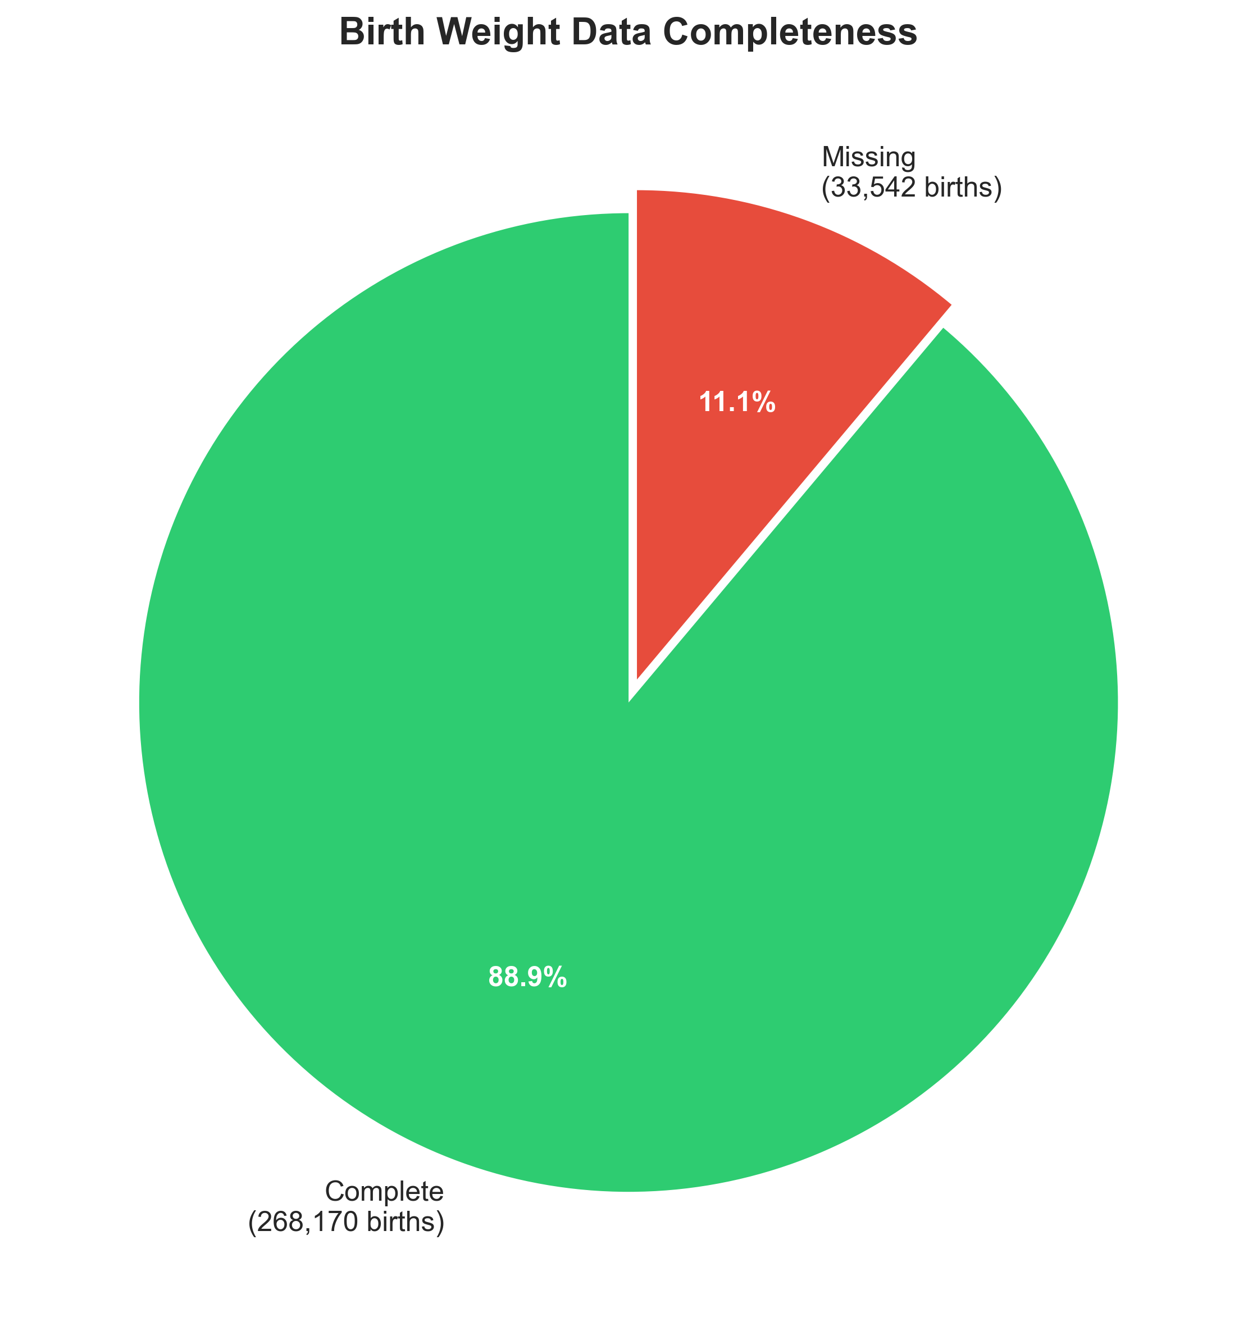
Figure 1: Overall birth weight data completeness.

2. IUPAC Ethnicity Classification System
The following ethnicity codes follow IUPAC standards for population genetics and vital statistics reporting:
IUPAC Code | Ethnicity | IUPAC Standard Name
SIN | Sinhalese | Sinhala
TAM_SL | Sri Lankan Tamil | Tamil (Sri Lanka)
TAM_IN | Indian Tamil | Tamil (India)
MOOR_SL | Sri Lankan Moor | Moor (Sri Lanka)
BUR | Burgher | Burgher
MAL | Malay | Malay
CHT_SL | Sri Lankan Chetty | Chetty
BHA | Bharatha | Bharatha
MOOR_IN | Indian Moor | Moor (India)
MOOR_PK | Pakistan Moor | Moor (Pakistan)
OTH_FGN | Other Foreigners | Other Nationalities
OTH_SL | Other Sri Lankans | Other Ethnic Groups

3. District-Wise Missing Birth Weight Analysis

Top Districts with Highest Missing Rates
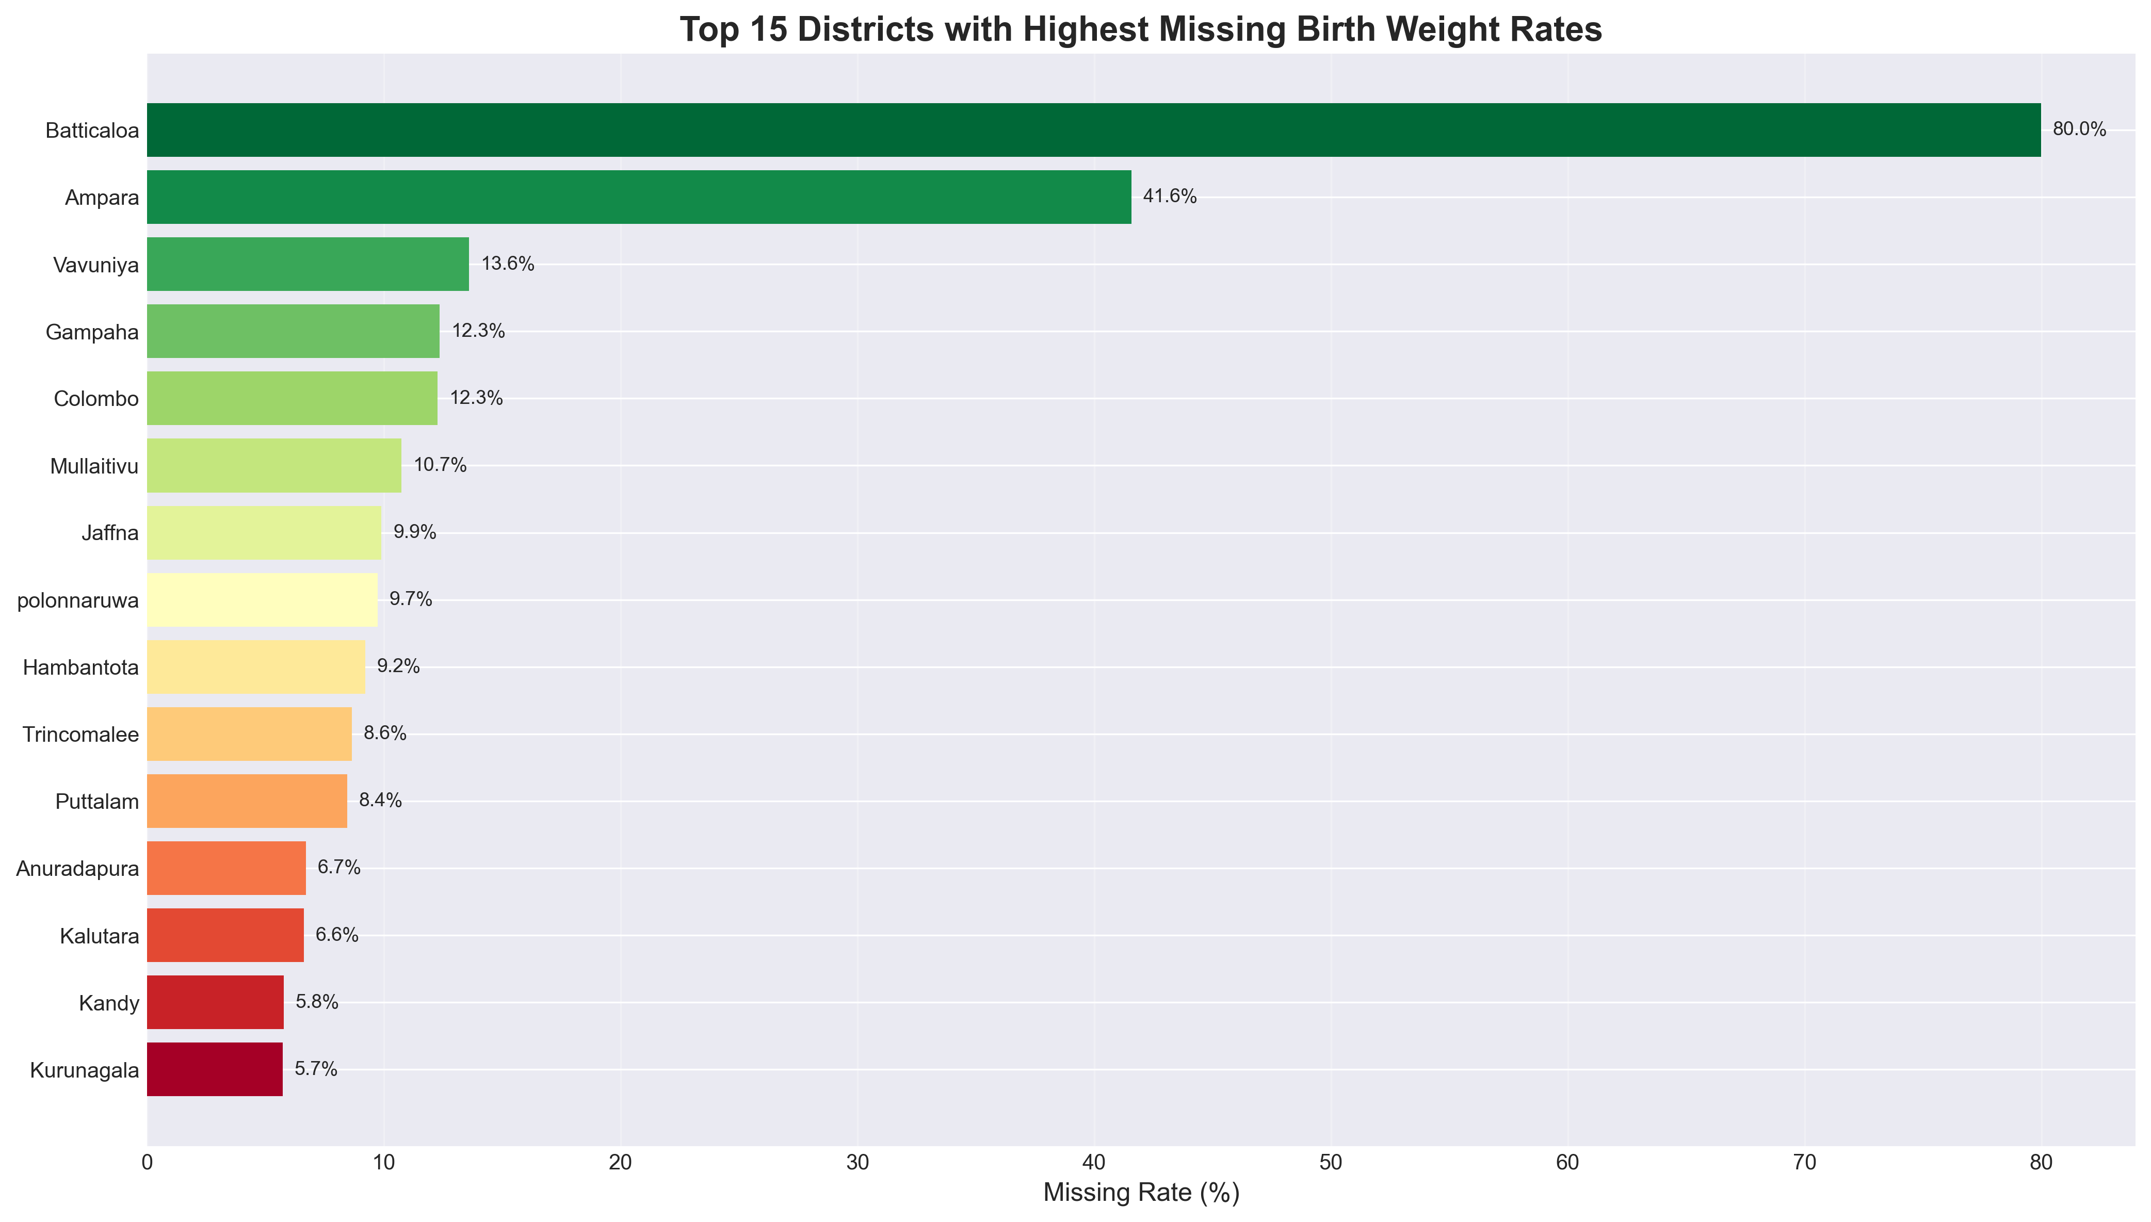
Figure 2: Top 15 districts with highest missing birth weight rates.

Distribution of Missing Rates
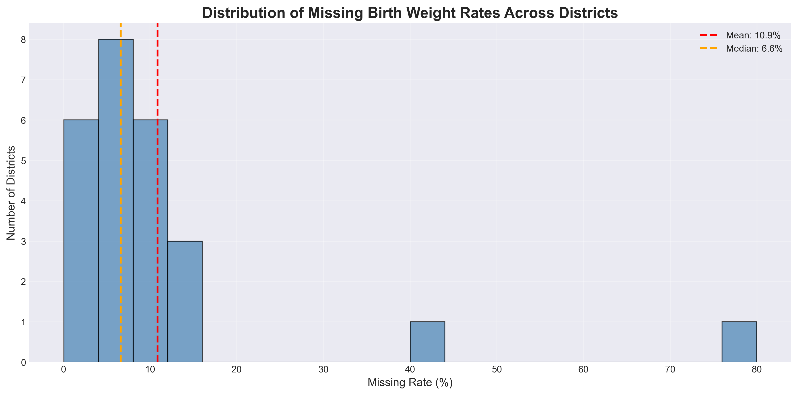
Figure 3: Distribution of missing birth weight rates across all districts.

3.1 District Summary Statistics
District | Total Births | Missing Records | Missing Rate (%)
Batticaloa | 9,566 | 7,651 | 79.98%
Ampara | 14,527 | 6,039 | 41.57%
Vavuniya | 3,743 | 509 | 13.60%
Gampaha | 19,262 | 2,378 | 12.35%
Colombo | 42,720 | 5,243 | 12.27%
Mullaitivu | 903 | 97 | 10.74%
Jaffna | 8,495 | 841 | 9.90%
polonnaruwa | 6,559 | 638 | 9.73%
Hambantota | 9,704 | 894 | 9.21%
Trincomalee | 8,443 | 730 | 8.65%
Puttalam | 12,344 | 1,043 | 8.45%
Anuradapura | 14,129 | 948 | 6.71%
Kalutara | 11,662 | 772 | 6.62%
Kandy | 24,366 | 1,404 | 5.76%
Kurunagala | 20,741 | 1,188 | 5.73%
Nuwara Eliya | 8,298 | 471 | 5.68%
Matale | 7,735 | 414 | 5.35%
Ratnapura | 17,178 | 918 | 5.34%
Kegalle | 8,800 | 359 | 4.08%
Matara | 9,883 | 261 | 2.64%

Relationship Between Total Births and Missing Records
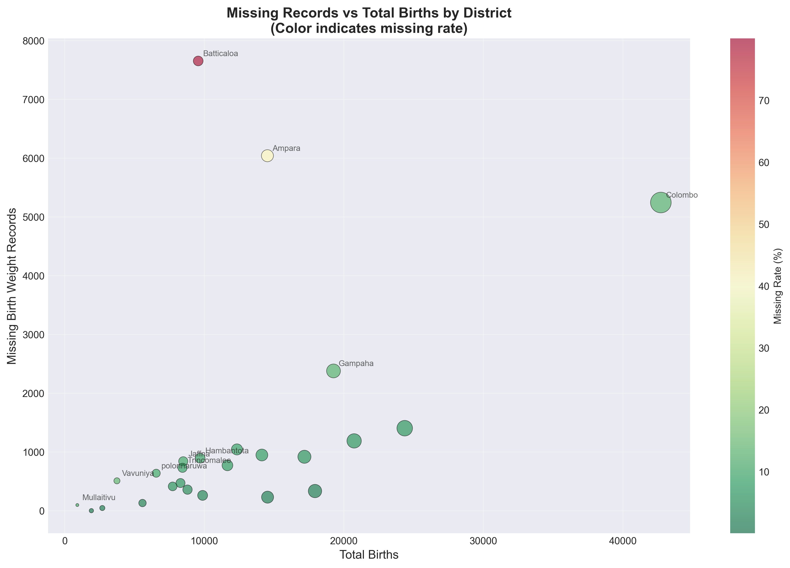
Figure 4: Scatter plot showing relationship between total births and missing records.

4. Ethnicity-Specific Analysis

Missing Rates by Ethnicity
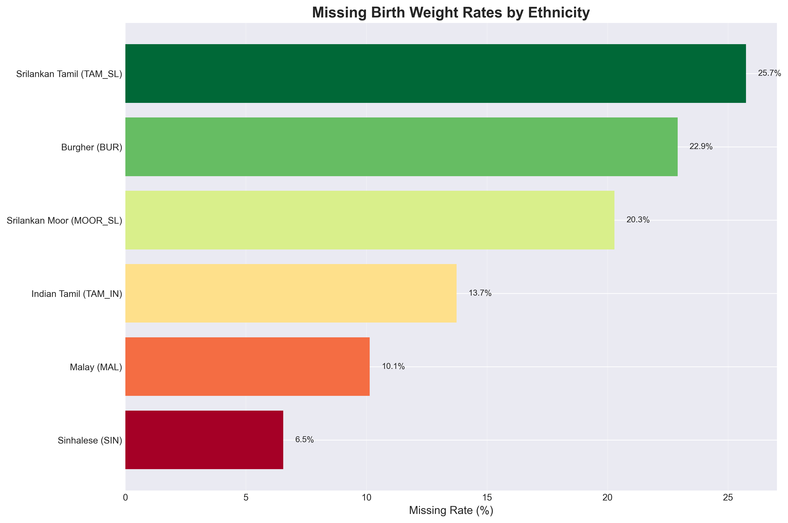
Figure 5: Missing birth weight rates by ethnicity (IUPAC codes shown).

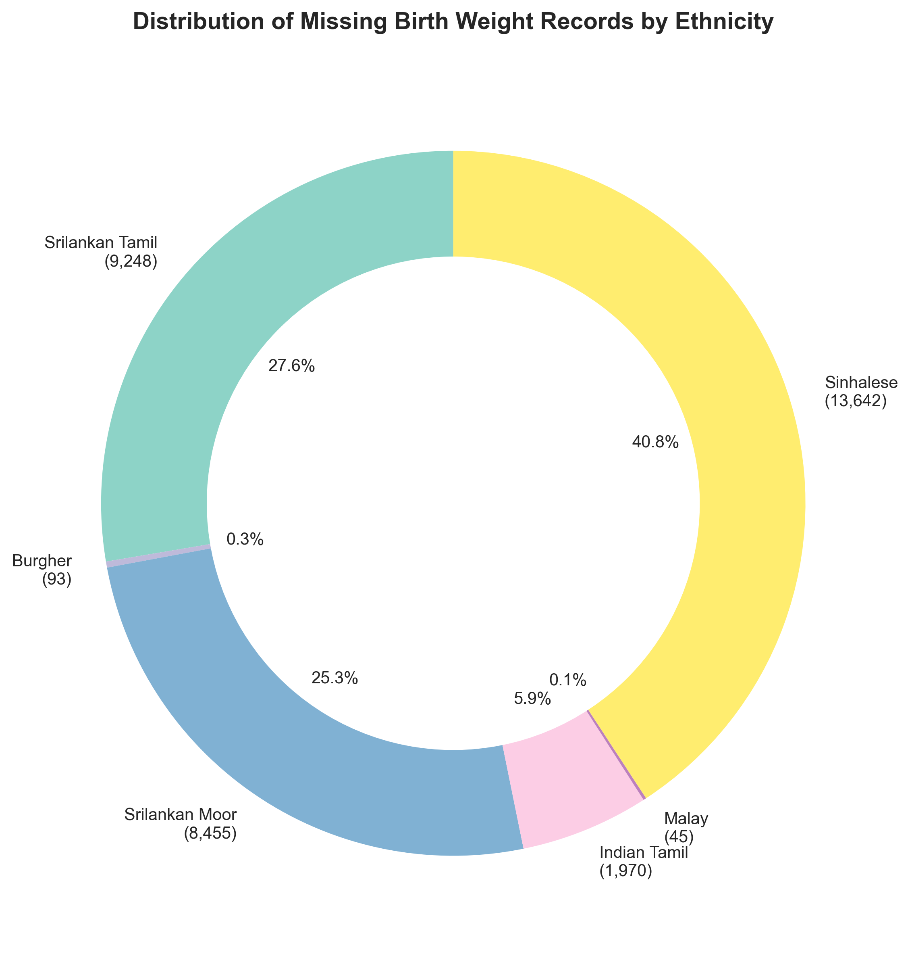
Figure 6: Distribution of missing records across ethnic groups.

Variability in Missing Rates by Ethnicity
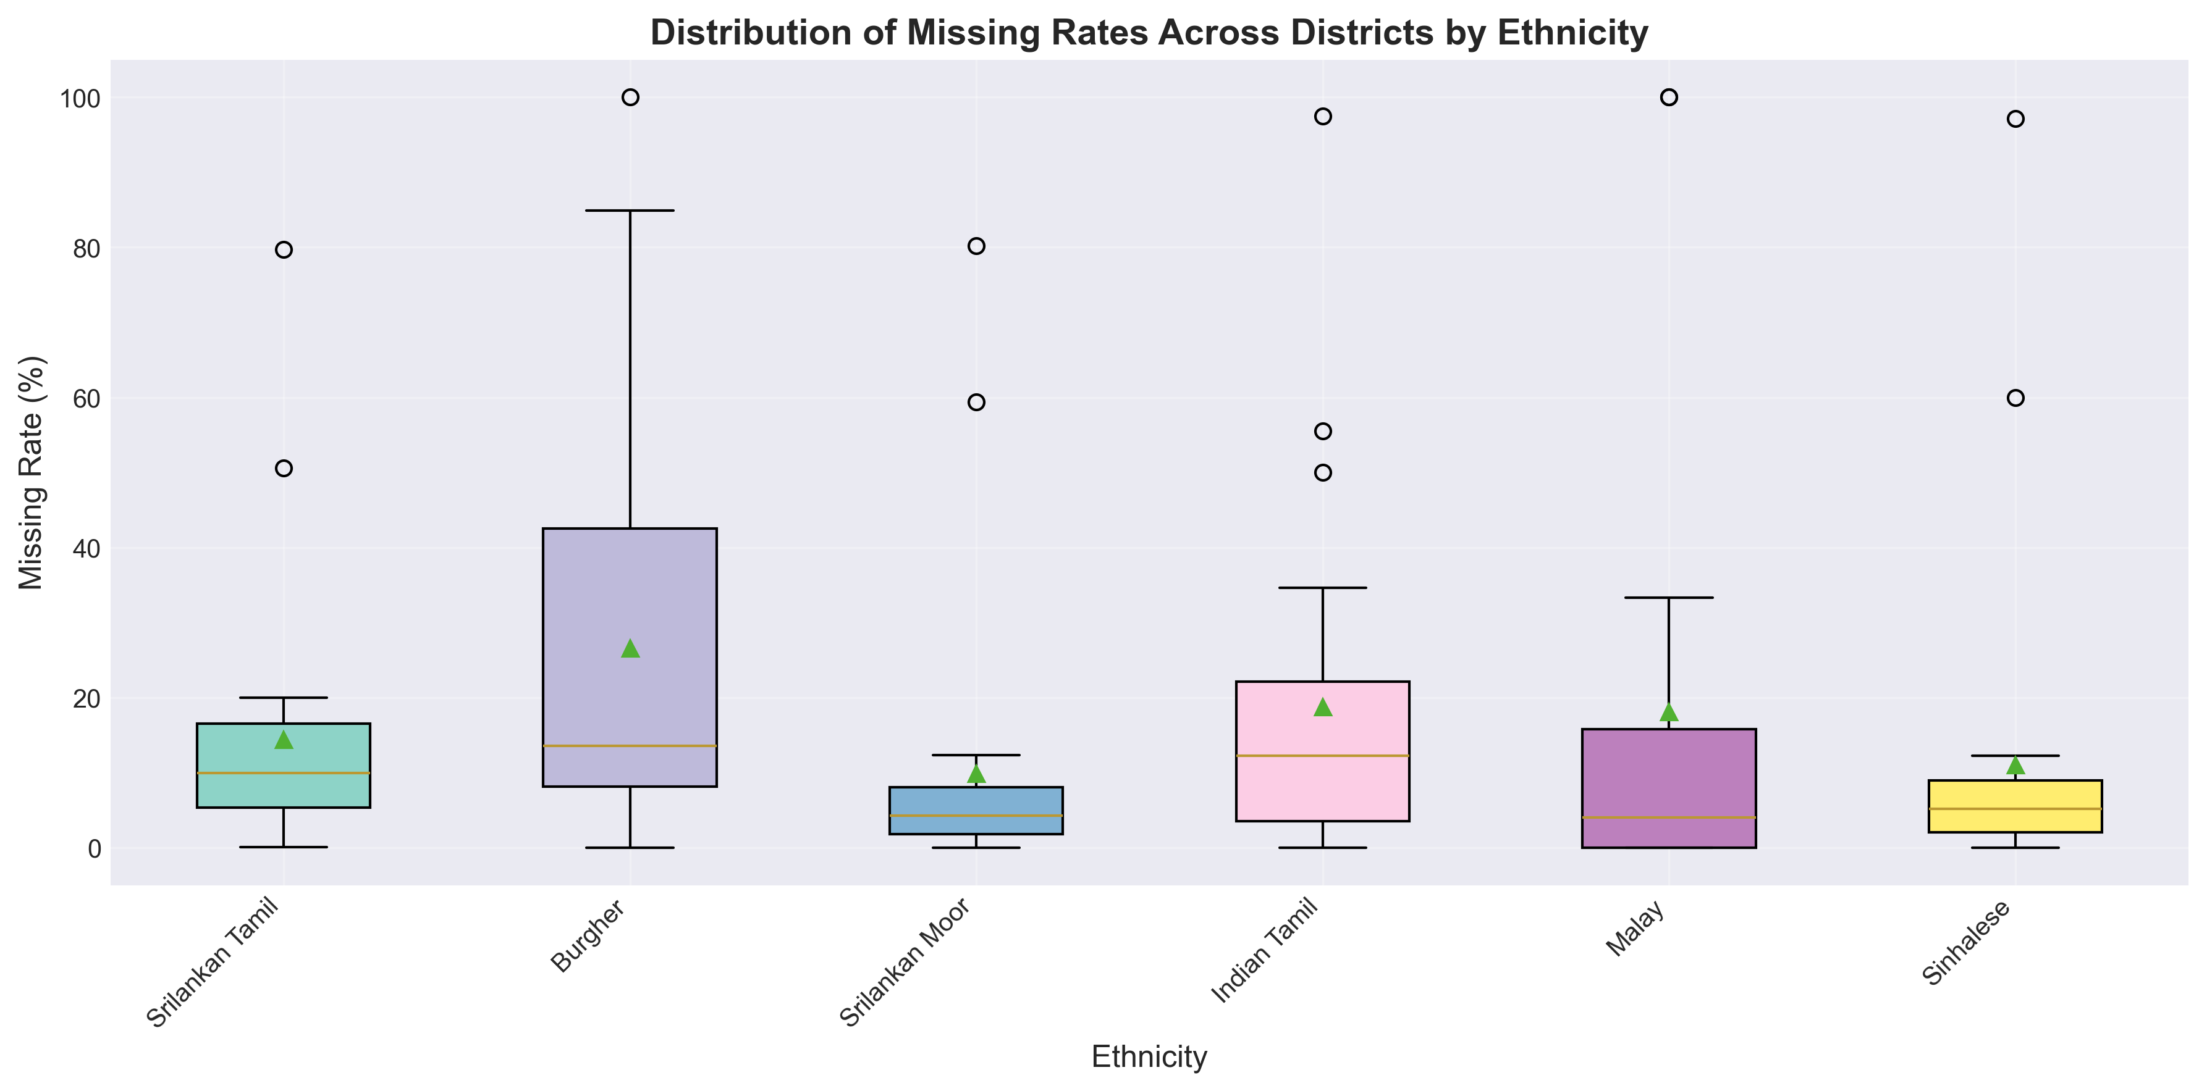
Figure 7: Box plot showing distribution of missing rates across districts for each ethnicity.

4.1 Overall Ethnicity Statistics
IUPAC Code | Ethnicity | Total Births | Missing Records | Missing Rate (%)
TAM_SL | Srilankan Tamil | 35,928 | 9,248 | 25.74%
BUR | Burgher | 406 | 93 | 22.91%
MOOR_SL | Srilankan Moor | 41,678 | 8,455 | 20.29%
TAM_IN | Indian Tamil | 14,341 | 1,970 | 13.74%
MAL | Malay | 444 | 45 | 10.14%
SIN | Sinhalese | 208,395 | 13,642 | 6.55%

4.2 District-Ethnicity Interaction Analysis
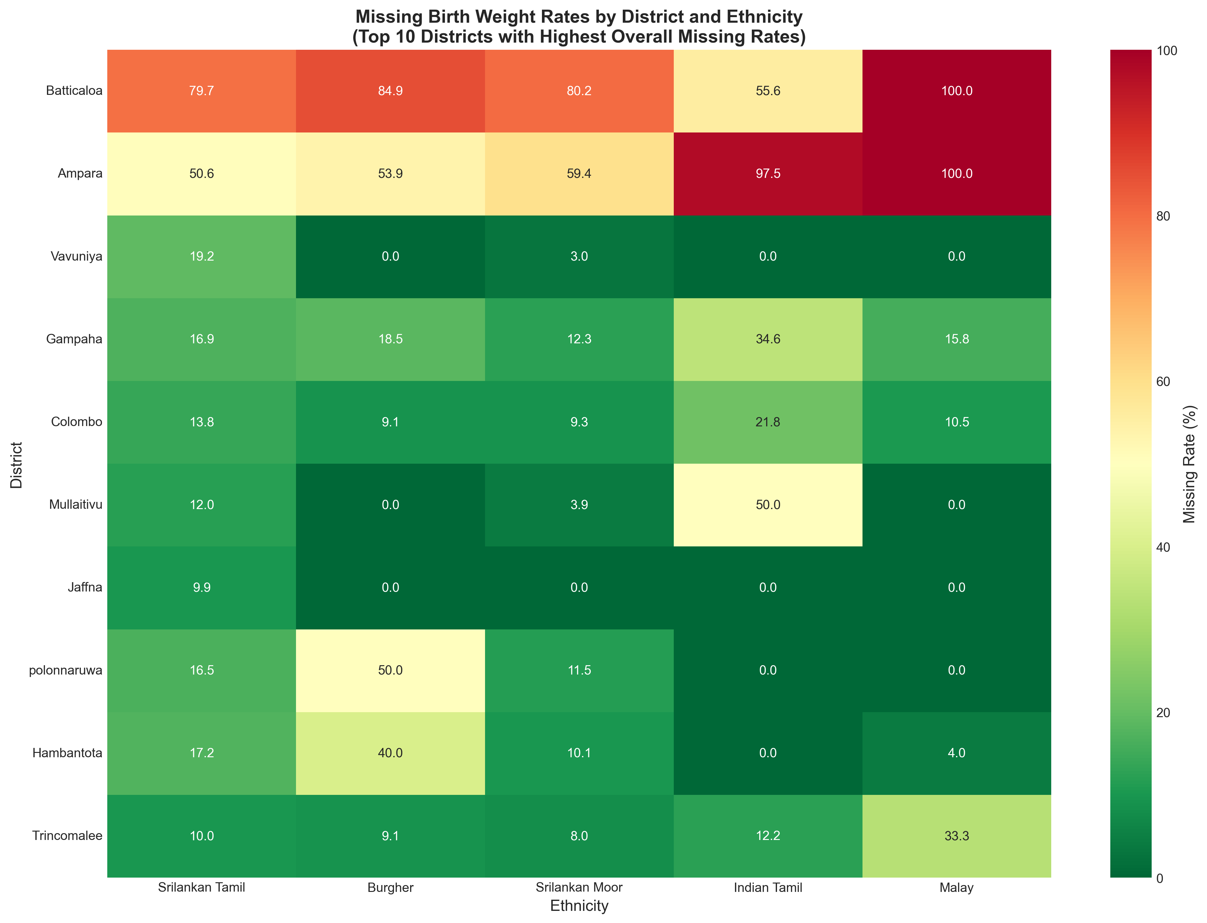
Figure 8: Heatmap showing missing rates by district and ethnicity.

5. Conclusions and Recommendations
5.1 Key Findings
• Data Completeness: 88.88% of birth records have complete birth weight data,
indicating 11.12% of records require data quality improvement.
• Geographic Disparities: Batticaloa shows the highest missing rate at
79.98%, suggesting potential data collection challenges in this region.
• Ethnic Disparities: Srilankan Tamil (TAM_SL) has the highest
missing rate at 25.74%, indicating potential systematic bias in data
collection across ethnic groups.
5.2 Recommendations
1. Standardize Data Collection Protocols: Implement uniform birth weight recording procedures across all districts,
particularly in high-missing-rate regions.
2. Ethnicity-Specific Interventions: Develop targeted data quality improvement programs for ethnic groups
with high missing rates, respecting cultural and linguistic sensitivities.
3. IUPAC Compliance: Maintain adherence to IUPAC ethnic nomenclature standards to ensure international
comparability and scientific rigor.
4. Regular Monitoring: Establish quarterly data quality monitoring systems to track improvements in
missing birth weight rates by district and ethnicity.
5. Capacity Building: Provide training for healthcare workers on the importance of complete birth weight
documentation, especially in districts with high missing rates.

